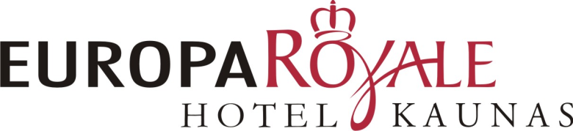
Europa Royale Kaunas Hotel
Hotel address: Miško g. 11, Kaunas, LT-44321
Hotel parking: Gedimino g. 10
Tel.: (8-37) 407 500
Fax.: (8-37) 407 501
e-mail: sm.kaunas@europaroyale.com

RESERVATION FORM FOR EVENT OF
LSGVGA 20-iest conference
25-26th of September, 2015
Please, book the hotel rooms before the until 4th of September. Later hotel rooms may not be available or the prices may increase.

GUEST NAME: _________________________________________________________________
ADDRESS: _________________________________________________________________
PHONE: _________________________________________________________________
MOBILE PHONE: _________________________________________________________________
E-MAIL: _________________________________________________________________
DATE: _________________________________________________________________

RESERVATION FORM

ARRIVAL DATE: _________________________ Time:___________
DEPARTURE DATE: _________________________

REQUIRED ROOM TYPE: REQUIRED ROOM QUANTITY: SPECIAL EVENT RATE:
SINGLE ROOM (1 person): ____________ 50 EUR
DOUBLE ROOM (2 persons) : ____________ 55 EUR
TWIN ROOM: (2 persons) ____________ 55 EUR

*Room rate includes accommodation, breakfast, car parking place and VAT. The official exchange rate is 1 EUR = 3,4528 LTL
* Animals are allowed on request. Charges may be applicable.

SPECIAL REQUESTS/NOTE: _____________________________________________________________________________________________________

Payment details:
- Credit card □ City ledger in advance □ In cash on spot

CREDIT CARD details to guarantee reservation is a must:
CC no. ______ - ______ - ______ -_______ VALID ___/___ CRV code _____

Necessary order confirmation: □ YES □ NO
Guarantee Policy: All reservations require credit card guarantee due at time of booking.
Cancellation Policy: Reservations must be cancelled 24 hours prior to arrival to avoid a penalty of one night room and tax.

________________________________________
(Name, surname, signature)

YOU ARE ALWAYS WELCOME AT EUROPA ROYALE KAUNAS HOTEL!

